Affordable Northside Home for Sale:
1913 Northwestern Ave.
Madison, WI 53704
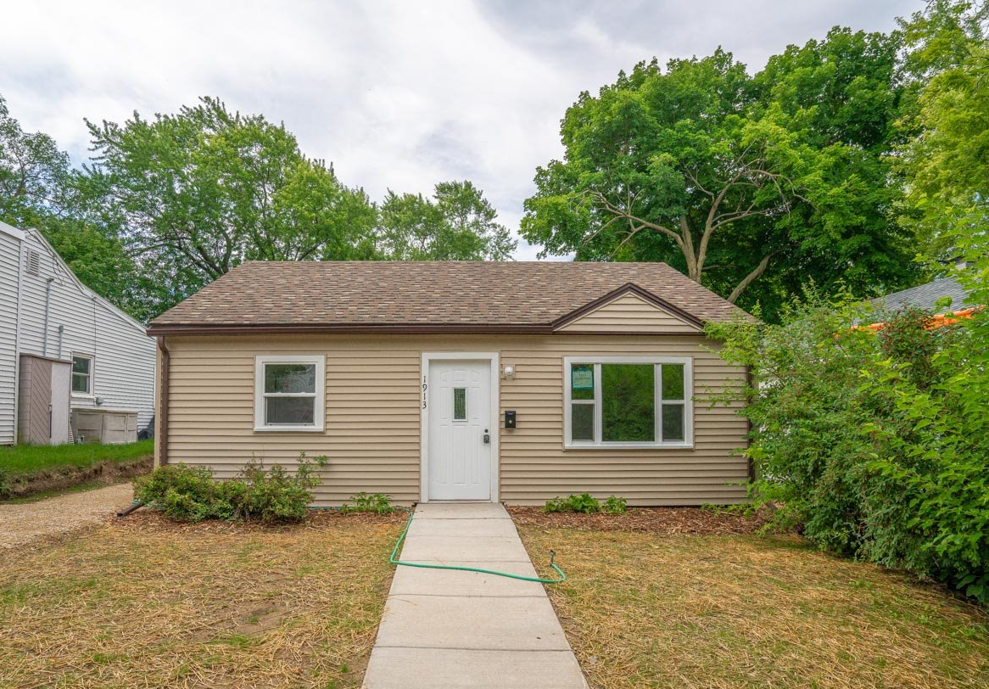
- Zero Barrier Northside Cottage-style home: $165,000
- Main floor: 714 sq ft. 2 small bedrooms, 1 bath with Luxury Vinyl Plank floors
- Single floor home with direct front door accessibility and no stairs within the home
- Large fenced-in back yard with large shed for lawn tools
- New flooring, interior paint, furnace, washer and dryer
- New roof, insulation, windows, and siding
This home is a permanently-affordable Community Land Trust (CLT) home. Under the CLT model, you would purchase the house, but not the land. The home is cheaper because you are only buying the house and not the land. You get to use the land as if you own it, but you hold a ground lease with the CLT. The ground lease sets a resale formula for when you move out. You buy your house at a below-market-rate price -- and in return, if you ever sell your land trust home, you agree to sell your home to another income-eligible household at a below-market-rate price. The resale formula, which governs the resale price, is pretty simple: you get (a) what you paid for the home, plus (b) 25% of the increase in market value.
You can stay in your home as long as you live -- and you can pass it along to your children or other member of your household, so long as they are below the income requirements. Or you can resell and get back the equity you put in, plus some on top.
The CLT model helps keep land affordable for future generations to meet the needs of the community. You can learn more at www.affordablehome.org. Note that to qualify to buy this house, the following conditions must apply:
ELIGIBILITY CRITERIA FOR THIS HOME
- Household income must be below 80% county median income (see table below)
- You must not own other property at the time of closing
- The maximum amount of “liquid assets” that you can have in reserves after closing cannot exceed the equivalent of twelve months of Principal, Interest, Taxes, Insurance and lease fees
- Submit a program pre-application to determine eligibility
- Attend an MACLT orientation with staff
- Be pre-approved for a mortgage at the value of the house available, with necessary down-payment or down-payment assistance
- Attend a HUD certified homeowner education workshop (completion certificate valid for 18 months)
You should first fill out our MACLT Pre-application and send it to housing@maclt.org to begin the process! Pre-applications should be submitted as soon as possible. All other eligibility criteria do not need to be met in any order; however, all must be met before a prospective buyer can close on a CLT home. If multiple people are interested in a home, a top buyer will be selected according to an equity-based point system in place at MACLT.
2022 Maximum household gross (before taxes) income limit (80% Dane County Median):
Household Size | Income Limit
1 | $62,600
2 | $71,550
3 | $80,500
4 | $89,400
5 | $96,600
6 | $103,750
7 | $110,900
8 | $118,050

MORE PHOTOS BELOW

Kitchen
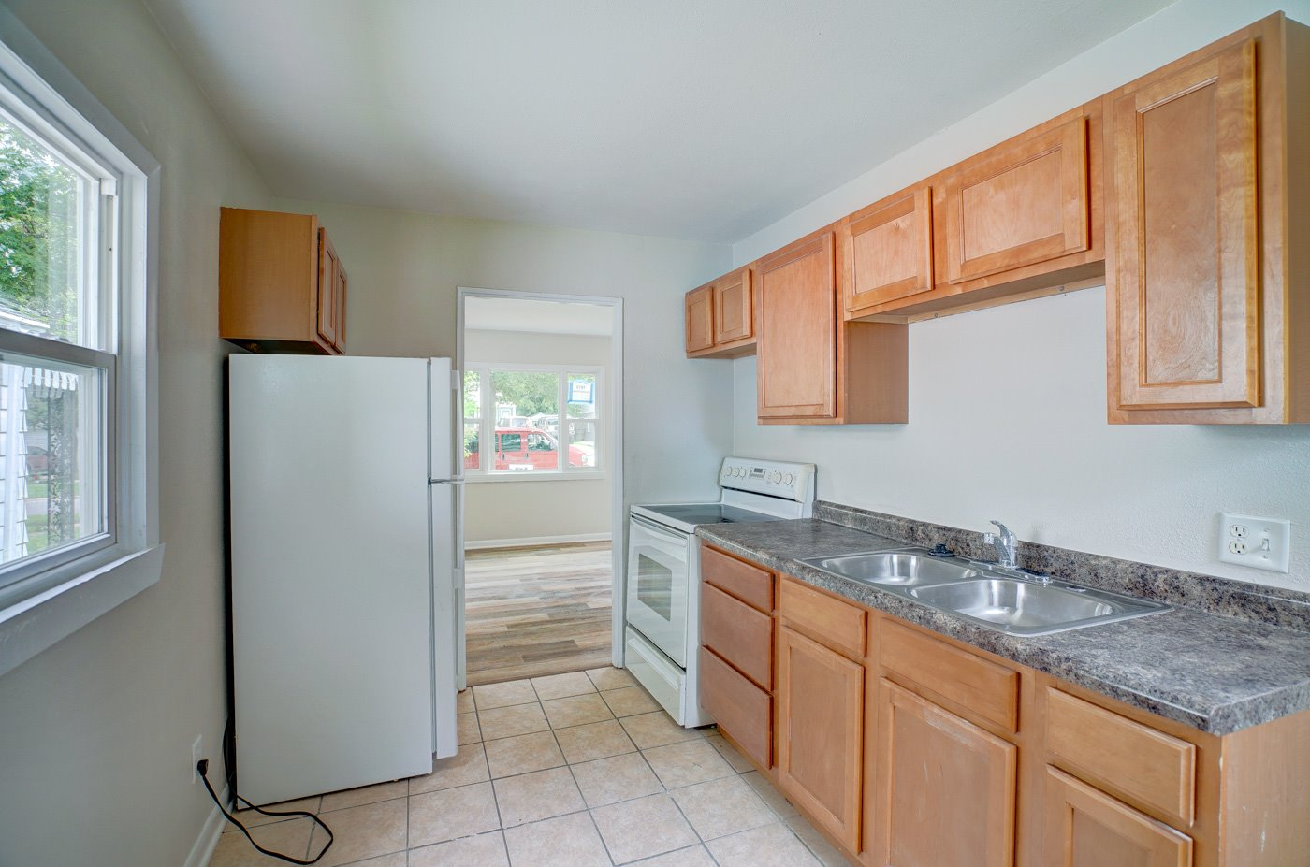

Bathroom
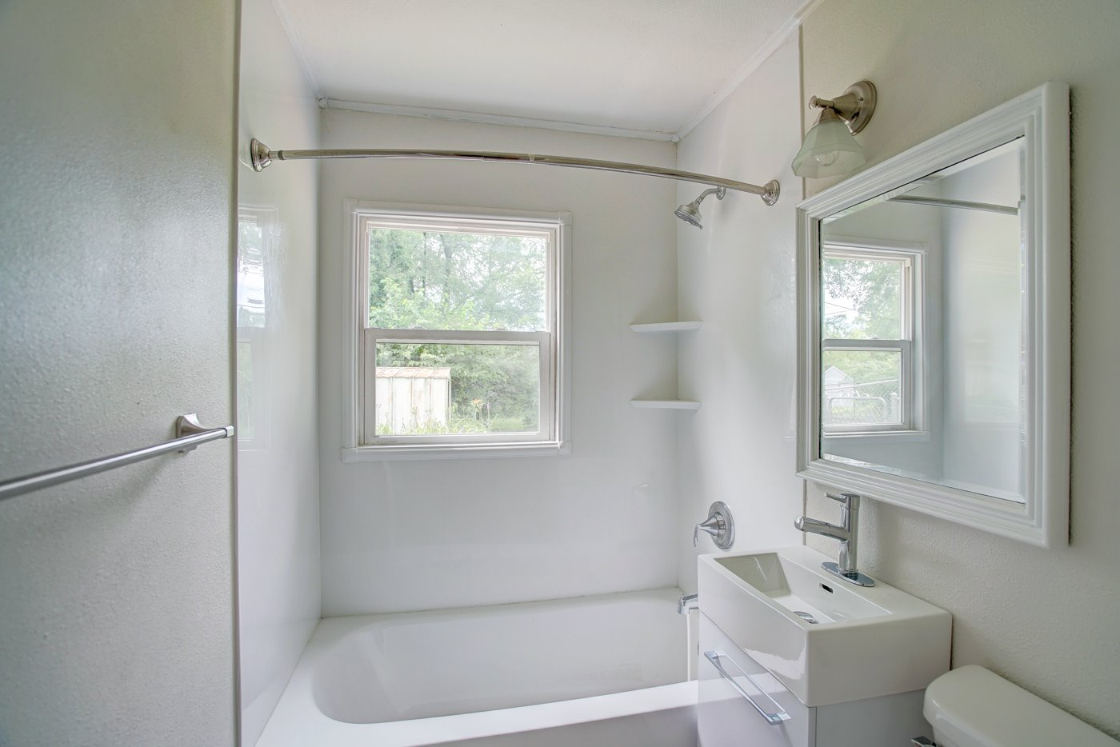

Bedroom 1
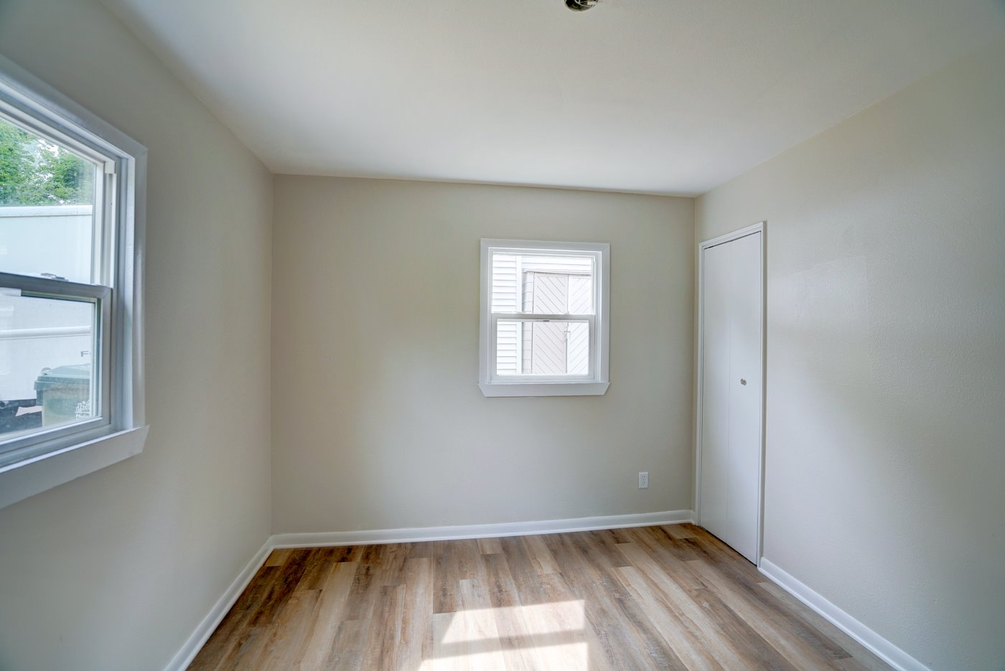
Bedroom 2
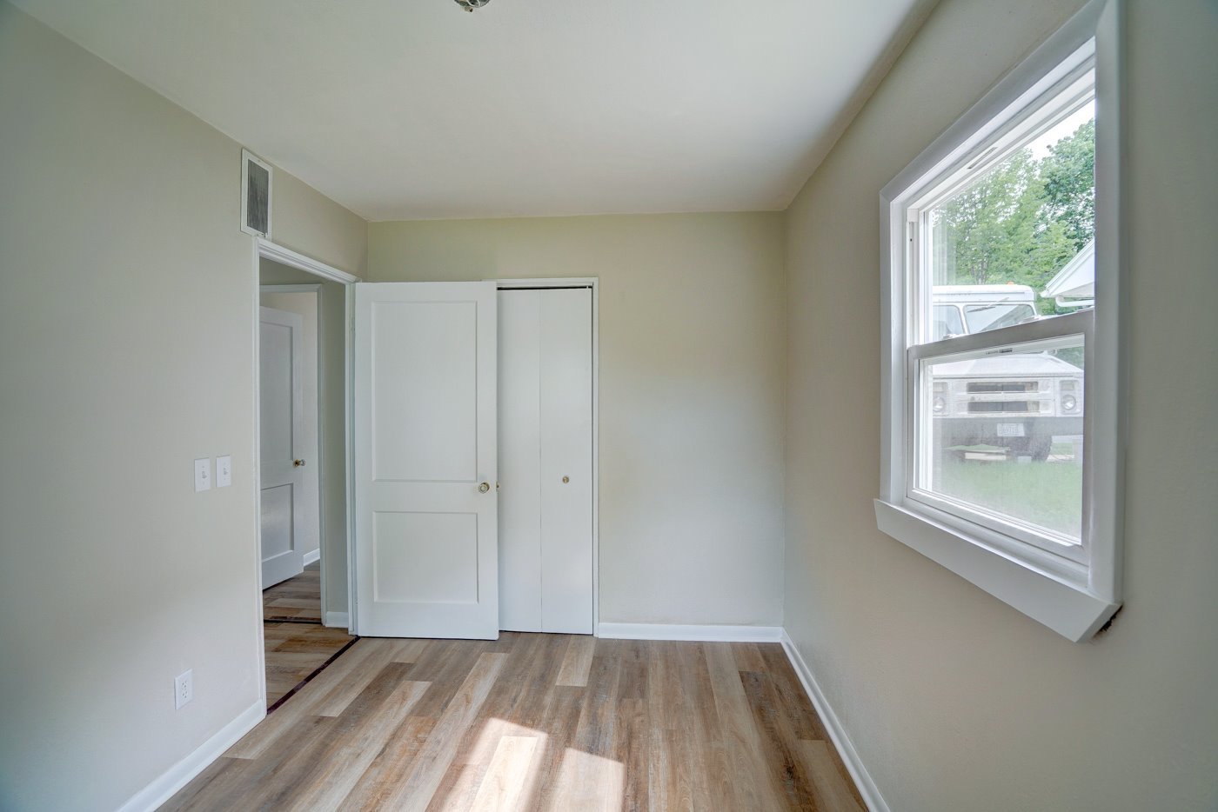

Living Room
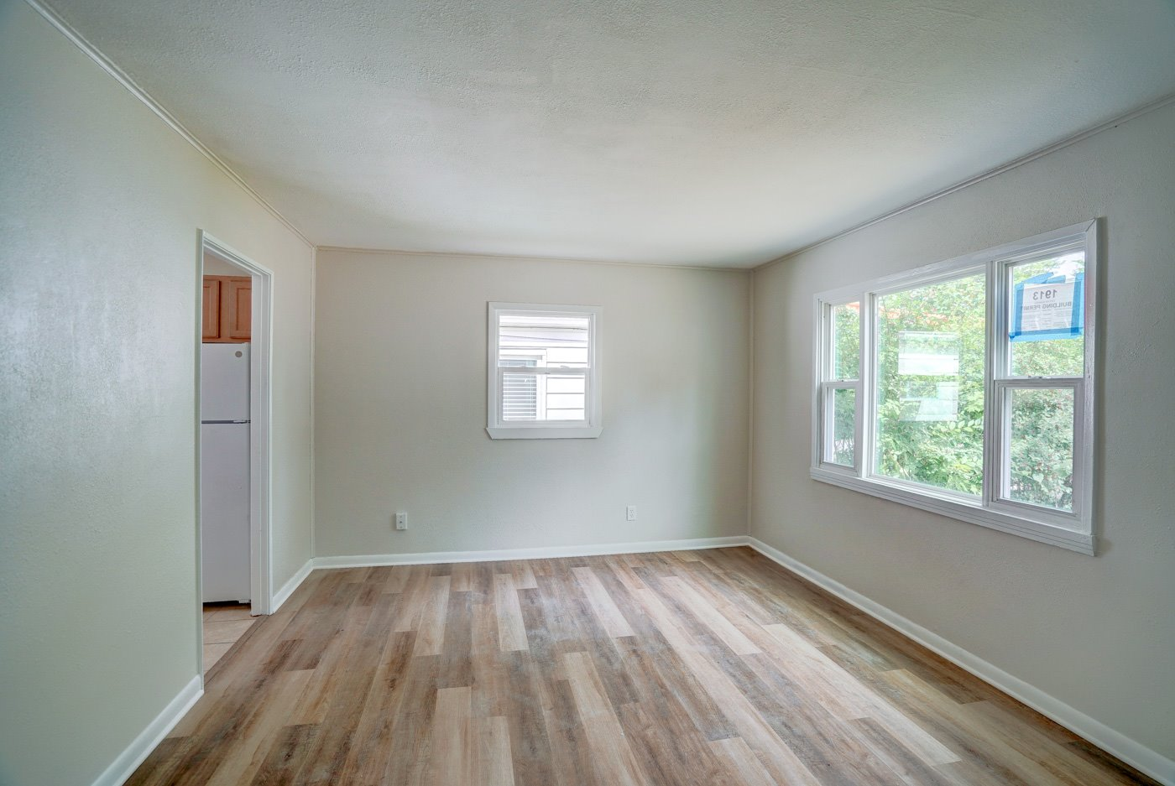
Laundry/Mechanical Room and Back Door
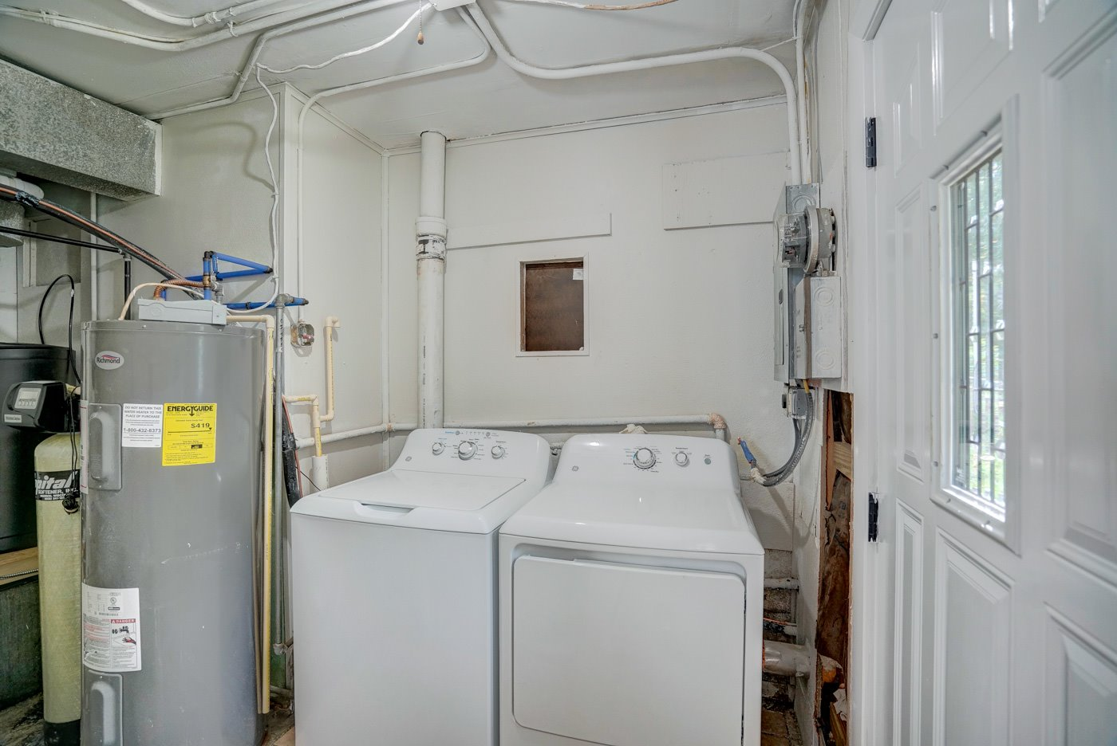

Backyard
